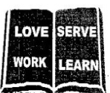
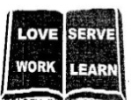
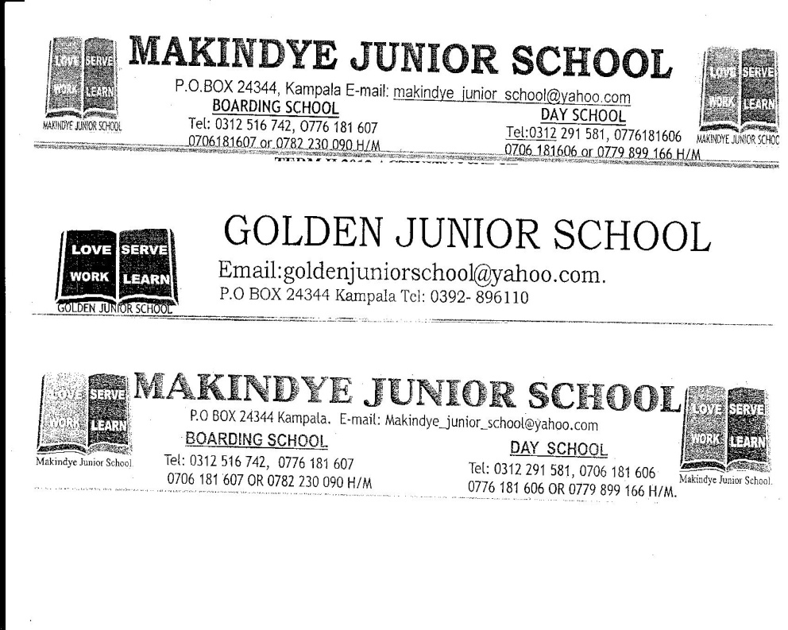
THE REAL SCHOOLS
LEARNER’S EMPOWERMENT ACTIVITIES
P.6 TERM I 2025 ENGLISH LANGUAGE
DEBATING

Victoria P/S

Golden Junior
School

Makindye Junior School

An excellent first grade and excellent character for every pupil

NAME:………………………………………………………………………CLASS: …………………………
SCHOOL: ………………………………………………………………………………………………………..
TOPIC: DEBATING
SUB TOPIC: DEBATING
LESSON ONE
Competences:
- vocabulary related to debating.
- forming plural of compound nouns.
- forming plural of common nouns from “f” to “ves”.
- forming plural of common nouns that end in “f” but add “s”.
- forming adverbs that add “ly”.
- forming opposite of words that by adding prefix “in”.
- comparing adverbs.
- forming opposites of words by adding prefix “olis”
Learning outcome:
In this session, you will be able to understand;
- Vocabulary related to Debating.
- Form plurals of nouns.
- Form adverbs that add “ly”.
- Form opposites of words.
- Compare adverbs.
Relevancy:
- This will help you know to debate and build confidence, self-express among learners.
Life skills
▪Effective communication ▪Critical thinking
Values
▪Love
▪Care.
▪Sharing
Lesson number 1
Teacher’s guidance.
Vocabulary related to debating.
Guiding questions
Write five vocabulary that you know in this topic.
Key learning principle
Vocabulary are new words used in each topic.
Speakers: People speaking in the debate to a group of people.
Timekeeper: An official who record the time taken by different speakers in a debate.
Secretary: An official who records the point given out by different speakers in debate.
Chairman: An official who controls and directs all activities in a debate.
Arguments: A reason that you use for persuading other people to support your views or options.
Argue: To discuss something with someone who has a different opinion from you.
Point: An idea or opinion.
Audience: A group of people who have come to a place to watch a performance or listen to a speech.
Current: Happening or existing now.
Conclude: To end a speech or any presentation.
Opinion: Your thoughts about something especially how good or bad it is.
Proposer: A person who speakers in support of the motion in debate.
Constructing some sentences using the new words.
1. The time keeper has sounded the warning bell for current speaker to leave the floor.
2. At what time will the secretary read out our points?
3. The opposer and the proposer argued with each other for close to two minutes.
Mini activity
Use the dictionary to look up the meanings.
1. opninon____________________________________________________________________
2. motion ____________________________________________________________________
3. oppose ____________________________________________________________________
4. role ____________________________________________________________________
5. point of inquiry ______________________________________________________________
6. point of information __________________________________________________________
Use the correct form of the words given in the brackets to complete the sentence.
7. The _________________________ we had ended in total disagreement. (discuss)
8. Last week’s debate was full of hot ________________________. (argue)
9. What an enjoyable activity _____________________ is! (debate)
10. Debates allow the audience to present their _____________________ on various topics. (opinion)
Competence 2
Forming plural of compound nouns.
key learning principle:
Compound nouns are nouns with more than one mound.
Some of the compound nouns take hyphen while others don’t.
Learner centred approach
In your groups, discuss about compound nouns that you know.
Teacher’s guidance
Compound nouns that take a hyphen.
Forming plural of compound nouns.
Singular Plural
passer-by passers-by
sister-in-law sisters-in-law.
head-of-state heads-of-state
prefect-on-duty prefects-on-duty
master-of-duty masters-of-duty
commander-in-chief commanders-in-chief
guest—of-honour ____________________________________________
father-in-law ____________________________________________
officer-in-charge ____________________________________________
stepson ____________________________________________
stepmother ____________________________________________
x-ray x-rays
Constructing sentences using the compound nouns.
1. The baby was given a spoonful of medicine.
2. Tugs-of-war is an interesting game.
3. That member-of-state is going to be transferred.
Activity
Rewrite the sentences giving the plural forms of the underlined words.
1. Our head-of-departments is very hardworking.
_____________________________________________________________________________
2. A toothbrush is sold in our shop.
_____________________________________________________________________________
3. That member- of -staff is going to be transferred.
_____________________________________________________________________________
4. Who is the prefect- on -duty this week?
_____________________________________________________________________________
5. We saw many head of cattle at the road side.
_____________________________________________________________________________
6. The passer by has escaped from prison.
_____________________________________________________________________________
7. The rebels are fought by the commander-in-chief.
_____________________________________________________________________________
Construct sentences using the following words.
8. passer-by ____________________________________________________________________
9. egg-plant ____________________________________________________________________
10. check-up ____________________________________________________________________
11. foot-paths ___________________________________________________________________
12. girl-guides ___________________________________________________________________
13. fathers-in-law ________________________________________________________________
14. guests-of-honour _____________________________________________________________
15. toothbrushes _________________________________________________________________
COMPETENCE 3
Forming plural of common nouns from “f” to “ves”.
key learning principle
Common nouns are used to name only one class, people, place ot things e.g girl, tree, town.
Learner centred activity
In your group discuss about the common nouns that you know.
Teacher’s guidance
Nouns that end in “f” ot “fe” form their plural by adding “ves”
Singular Plural
wolf wolves
life lives
calf calves
dwarf dwarves
shelf shelves
hoof hooves
elf elves
knife knives
Exceptionals that end in “f” but just add “s”
roof roofs
cliff cliffs
Activity
Complete the table below correctly.
Singular | Plural
reef  chef  handkerchief  thief  wolf | _______________________________  _______________________________  _______________________________  _______________________________  _______________________________
Constructing sentences using the common nouns.
1. The leaf fell from the tree.
2. The thieves stole watches and boxes of jeweries.
3. A wolf killed a sheep.
Mini activity
Complete each of the sentences below using the pleural form of the noun given in brackets.
1. Mother told me to clean all the dirty _________________________. (shelf)
2. Two of the internet _____________________ have been closed. (café)
3. Kaggwa’s blouse was full of __________________________. (patch)
4. _______________________ transport passengers going upcountry, (bus)
5. Some _____________________ do not have respect for their employees. (boss)
6. The story of the four _________________________ was very interesting indeed. (elf)
CONPETENCE FOUR
Forming adverbs that add “ly’
Key learning principles.
Adverbs that add suffix “ly” to the adjective end in following words “ful, ed, less, ble, ing”.
Learner centred approach
Write ten adjectives that end in the following:
less, ble, ful
___________________________________ ______________________________________
___________________________________ ______________________________________
___________________________________ ______________________________________
___________________________________ ______________________________________
___________________________________ ______________________________________
Teacher’s guidance
Adverbs are formed from adjectives.
Examples
Adverbs are formed from adjectives/
Examples
Adjective Adverb
careless carelessly
faithful faithfulness
reckless recklessly.
sorrowful sorrowfully
merciless mercilessly
quiet quietly
brief __________________________________
awkward __________________________________
painful __________________________________
peaceful __________________________________
brief __________________________________
grateful __________________________________
Construct the sentences using the formed adverbs.
1. The boys were gently dressed.
2. The woman who cruelly beat up her son was jailed.
Mini activity
Complete table below correctly.
cheerful  excited  achievable  able  possible | _______________________________  _______________________________  _______________________________  _______________________________  _______________________________
Complete the following sentences using the given words in the brackets.
1. The pupils _________________ boarded the school bus. (cheer)
2. Justine Brown walks _________________________. (lazy)
3. He _________________________ mentioned his best friend’s name. (public)
4. Debates are not for pupils who speak _______________________. (shy)
5. Anyone who drives ______________________ kill be arrested by the traffic police. (reckless)
competence five
Comparing adverbs
K.L.P: Adverbs are words that tell us more about a verb, an adjective or another adverbs.
Learner centred approach.
In your groups, discuss about different adverbs that you know.
Teacher’s guidance
Examples of adverbs.
adverb of time, adverb of place, adverb manner.
Comparative degree, we compare two things.
Superlative degree, we compare three things and above.
Positive degree Comparative degree Superlative degree
awkwardly more awkwardly most awkwardly
painfully more painfully most painfully
briefly more briefly most briefly
quietly ______________________ ________________________
madly ______________________ ________________________
gratefully ______________________ ________________________
practically ______________________ ________________________
easily ______________________ ________________________
shabbily ______________________ ________________________
merrily ______________________ ________________________
clumsily ______________________ ________________________
crazily ______________________ ________________________
luckily ______________________ ________________________
Competence six
Forming opposite of words that add prefix “dis”
K.L.P: A prefix is a letter or group of letters added to the beginning of the word change its meaning/opposite is something that is different.
Teacher’s guidance
Prefix is added just before a word.
Lerner’s centred approach
In your groups discuss about the words that are formed by adding a prefix.
CONTENT
Examples of the words and their opposites that are formed by adding prefix “dis” before the word.
Word Opposite
appear disappear
satisfied dissatisfied
comfort discomfort
honest dishonest
like dislike
respectful ________________________
courteous ________________________
allow ________________________
continue ________________________
believe ________________________
advantage ________________________
arm ________________________

Competence seven
Forming opposite of words that add “in”
K.L.P: Opposites is a word that is as different as possible from another.
Learner cetred approach
In your groups discuss about opposites of adjectives that you know.
Teacher’s guidance
A prefix is a letter or group of letters added to the beginning of a word to change its form.
Word Opposite
capable incapable
gratitude ingratitude
curable incurable
sane insane
complete ________________________
direct ________________________
depedent ________________________
attentive ________________________
equality ________________________
offensive ________________________
Mini activity
Rewrite the sentences giving the opposite of the underlined words.
1. Some people are efficient in their work.
_____________________________________________________________________________
2. I would like you to connect that electric wire.
_____________________________________________________________________________
3. You don’t have to bring complete homework with you.
_____________________________________________________________________________
4. Smoking marijuana is legal in Uganda.
_____________________________________________________________________________
5. Your house maid is a responsible person.
_____________________________________________________________________________
Construct sentences using the following:
more capable
_____________________________________________________________________________
most peacefully
_____________________________________________________________________________
disallow
_____________________________________________________________________________
more possibly
_____________________________________________________________________________
most hopelessly
_____________________________________________________________________________
MEGA ACTIVITY
Fill in the blank space with a suitable word.
It is the role of the __________________________ to record the time each speaker uses in a debate.
2. As soon _____________________ the secretary read the points the chairperson declared the debate ended.
3. That is the girl _______________________ gave many points during the debate.
4. Sometimes the _________________________ are not fair when awarding marks during debate.
Use the correct form of the word given in brackets to complete the sentences.
5. Both the ________________________ and the opposers were lively during the debate.
6. The debate ______________________written on the chalkboard. (clear)
7. We learnt about _____________________ speech yesterday. (direct)
8. The older you grow, the more ___________________________ you become. (knowledge)
9. Debate allow the audience to present their ____________________ on various topics. (opinion)
Give one word for the underlined word.
10. The people argued against the motion.
_____________________________________________________________________________
11. Our school will support the motion in the forthcoming debate.
_____________________________________________________________________________
Compete the table correctly
Word | Opposite
12. audible  13. sane  14. complete  15. direct  16. expensive  17. allow  18. continue  19. arm | _______________________________  _______________________________  _______________________________  _______________________________  _______________________________  _______________________________  _______________________________  _______________________________
Arrange the given words in Abc order.
20. point, prosper, audience, argue
_____________________________________________________________________________
21. chairman, motion current, conclude
_____________________________________________________________________________
22. timekeeper, secretary, speaker, oppose
_____________________________________________________________________________
LESSON TWO
TOPIC: DEBATING
SUB TOPIC: Debating
Competences
- Describing direct speech (parts and punctuations)
- Describing indirect speech(give all the necessary changes)
- Changing direct speech statements (positive and negative) in simple present tense to indirect speech.
Learning out come:
In this lesson, you will be able to understand direct speech, indirect speech and how to change from change from direct to indirect speech.
Relevancy
This will help you know to answer different questions about speech.
Life skills
Effective communication
Critical thinking
Value
Love
Care
Competence one
Describing direct speech (parts and punctuations)
Key learning principle
The direct speech quotes the actual words some one spoke or has spoken.
Guiding qtn
In your different groups discuss about sentences in simple present tense.
Teacher’s guidance
Direct speech sentences have two principle parts.
CONTENT
In direct speech sentences have two principles e.g
The speech tag
the actual words of the speaker
Examples of speech tags.
Said the chairperson
the second proposers answered
says Mr.Makanga
reported the journalist
Punctuating the direct speech
- When punctuating sentences in the direct speech, the following guidelines should be observed.
- Put the actual words of the speaker inside quotation marks.
- If the sentences begins with the speech tag, put a comma before the opening quotation marks.
- Use a capital letter after the opening quotation mark.
- If the person being addressed is part of the speaker’s actual words, use a comma to separate the name from the rest of the words.
Punctuation marks commonly used in the direct speech.
Opening and closing quotation marks  Comm  Full stop  Question mark  Exclamation mark | “ ”  ,  .  ?  !
Example of direct speech sentences
“I enjoy debating,” said Sarah.
words of the speaker speech tag
Nick said, “I enjoy debating.”
Speech tag actual words of the speaker.
Mini activity
Write five speech tags in this lesson.
1. ____________________________________________________________________________
2. ____________________________________________________________________________
3. ____________________________________________________________________________
4. ____________________________________________________________________________
5. ____________________________________________________________________________
Identify the speech tag, actual words of the speaker and punctuate correctly.
6. Send me that black pen. John said
____________________________________________________________________________
7. Bella says that the sun rises from the east.
____________________________________________________________________________
8. I participated in the debate said Vero.
____________________________________________________________________________
Competence two
Describing indirect speech
K.L.P: The reported speech is also known as the indirect speech.
In this speech, someone else reports the information that he has heard.
Teacher’s guidance
A reported speech sentence uses the tense expressed in the verb of reporting.
CONTENT
Changes used in reported speech.
When a sentence is changed from direct to indirect speech some parts of speech change from one form to another.
Major changes are:
direct speech Indirect speech
I he/she
me him/her
mine his/her
my his/her
we they
our their
us them
you we/me/us/them/him/her
your I /my/us/them/him/her
is/am ___________________________________________
are ___________________________________________
will/shall ___________________________________________
were/was ___________________________________________
must ___________________________________________
may ___________________________________________
today ___________________________________________
Examples of reported speech sentences.
1. Keith said that he wanted to present his point well that day.
2. The children said that they didn’t want to miss any debate that term.
Mini activity
1. Complete the table correctly.
Changes in the direct speech
Direct speech | Indirect speech
today | ______________________________
____________________________ | themselves
tomorrow | _______________________________
____________________________ | had to
bring | ________________________________
____________________________ | those
2. Identify the parts that are going to change from direct to indirect speech in the following sentences.
a) He said “I go for a walk very evening.”
pronoun ______________________________ to _________________________________
verb _______________________________ to _________________________________
b) Ali said, “I go for walk every evening.”
pronoun ______________________________ to _________________________________
verb _______________________________ to _________________________________
c) “We have finished our work,” the children said.
pronoun ______________________________ to _________________________________
verb _______________________________ to _________________________________
d) The little girl, “I read this book yesterday.”
pronoun ______________________________ to _________________________________
time _______________________________ to _________________________________
other changes _________________________ to __________________________________
Competence three
Changing direct speech sentences in simple present to indirect speech sentences.
K.L.P: Direct speech quotes the actual words someone spoke or has said.
The reported speech is also known as the indirect speech.
Learner’s guiding qtn)
In your groups discuss about some changes that take place in direct to indirect sentence.
Teacher’s guidance
In simple present tense we use the verb that is in everyday tense.
CONTENT
Indirect speech uses the tense expressed in the verb reporting.
Example of sentences
“I speak during debate,” said Akuta.
Akuta said that she spoke during debate.
2. “let the current speaker continue suggesting said the chairperson.
The chairperson said that let the current speaker continue suggesting.
3. “I must attend tonight’s debate,” said Luna.
Luna said that he had to attend that night’s debate.
Activity
Change the following sentences from direct to indirect speech.
1. “I read a lot of books in order to get knowledge,” said Karen.
____________________________________________________________________________
2. The secretary said, “I can defend myself.”
____________________________________________________________________________
3. He said, “Magala is late for the debate.”
____________________________________________________________________________
4. The chief whip said, “maintain silence please.”
____________________________________________________________________________
5. Our teacher says, “The sun rises in the east.”
____________________________________________________________________________
6. “Water boils at 100⁰C,” says our head teachers.
____________________________________________________________________________
Fill in the blank space with the correct form of the words given in the brackets.
1. Good __________________________ motivate their listeners. (speak)
2. Ken was one of the _______________________ during the debate. (oppose)
3. Do you know what the ______________________ is about? (argue)
4. You should raise a point of _____________________ through the chairman. (uniform)
5. They presented ___________________ views in a clear manner. (them)
Rewrite the sentences giving the opposite of the underlined words.
6. Your luggage is heavier than mine.
____________________________________________________________________________
7. Teacher always talk about careless children.
____________________________________________________________________________
Give the plural form.
8. point of inquiry _____________________________________________________________
9. index _____________________________________________________________________
Use these words in sentences to show that you understand their meaning.
10. seat ________________________________________________________________________
11. sit _________________________________________________________________________
Rewrite as instructed in the brackets.
12. James like chicken more than fish. (Use……………prefer………………..)
____________________________________________________________________________
13. It was a very educative debate. (Begin: What………………………)
____________________________________________________________________________
14. They went to the hall for a debate. The bell rang. (Use……….as soon as………….)
____________________________________________________________________________
15. If you are careless on the road, you will get an accident. (Begin: If…………………)
____________________________________________________________________________
In 100 to 150 words, write a free composition about debating, give the importance of debating, explain the people found in the debating club and their roles.
____________________________________________________________________________
____________________________________________________________________________
____________________________________________________________________________
____________________________________________________________________________
____________________________________________________________________________
____________________________________________________________________________
____________________________________________________________________________
____________________________________________________________________________
____________________________________________________________________________
____________________________________________________________________________
____________________________________________________________________________
____________________________________________________________________________
____________________________________________________________________________
____________________________________________________________________________
____________________________________________________________________________
LESSON THREE
TOPIC: DEBATING
SUB TOPIC: Debating
Competences
  - Changing direct speech statements in present continuous tense to indirect speech.
  - Changing direct speech statements in present perfect tense to indirect speech.
  - Changing direct speech statements in simple past.
  - Changing direct speech statements in simple future tense.
Learning outcome
In this lesson, you will be able to understand how to change speech statements to indirect in all tenses.
Relevancy
This will help you to know how to change direct to indirect sentences.
Life skills
Effective communication
Creative thinking
Values
love
care
Competence one
Changing direct speech sentences to indirect speech in present continuous tense.
key learning principle
This is the time that talks about things that are done now e.g talking debating e.t.c
Guiding question
In your group discuss about the things that you do in daily life.
Teacher’s guidance
The present continuous changes to past continuous tense.
Examples of direct speech sentences.
1. Jane said, “I am going to the clinic now.” (indirect speech statement)
2. Abasa said, “Nakirya is doing her homework. (direct speech)
Abasa said that Nakirya was doing her homework.
3. Joan said, “the audience is making noise.”
Joan said that the audience was making noise.
Competence two
Changing direct speech statements into indirect speech statements in present perfect tense.
Guiding question
In your different groups discuss about present perfect tense.
Teacher’s guidance
Present perfect changes to past perfect tense in indirect speech.
Changing direct speech sentence to indirect speech in present perfect tense.
1. She said, “The teacher has called me.” (direct speech)
She said that the teacher had called her. (indirect speech)
2. Kelly said, “Dan has drawn nice pictures.”
Kelly said that Dan had drawn nice pictures.
3. Kato complained, “Wasswa has eaten my mango.”
Kato complained that Wasswa had eaten his mango.
Competence three
Changing direct speech statements into past perfect tense or remain in the simple past.
Key learning principle
This is the tense that talks about things action that took place some time back.
Guiding question
In your group discuss about the activities that you did yesterday.
Teacher’s guidance
Simple past tense changes to past participle or remain in the simple past.
Content
Examples of sentences in simple past tense.
Our neighbour said., “I bought a new car.”
Our neiighbour said that he bought a new car.
The speaker said, “The proposers have won the debate.”
The speaker said that the proposers had won the debate.
or
The speaker said that the proposers won the debate.
Competence four
Changing direct speech sentences to indirect speech in simple future tense.
K.L.P: Simple future tense talks about activities things that take place in future.
Guiding question
In your group, discuss about thins that you think will take place tomorrow.
Changes in simple future in modal.
will/shall would
can could
may might
must had to
Sentences in simple future tense
1. “We will be there tomorrow,” Sarah said.
Sarah said that they would be there the next day.
2. Precious said, “I shall need some more money.”
Precious said that she would need some more money.
Mini activity
Rewrite as instructed in the brackets.
1. She said, “You must pay this money before 1st April.” (Change to reported speech)
____________________________________________________________________________
2. The chairperson said that the podcast had lost the debate. (Begin: The chairperson said,………………………..)
____________________________________________________________________________
3. Ciara said that she would look after the baby. (Change to reported speech)
____________________________________________________________________________
4. The chief whip said, “The language is correcting some people.” (Change to direct speech)
____________________________________________________________________________
5. “I am tired,” Jane said. (Change to indirect speech)
____________________________________________________________________________
MEGA ACTIVITY
Use the words given in the brackets to complete the sentences correctly.
1. They would remember the points if they _____________________ them down. (write)
2. The audience would doubt you if you _____________________ to them. (lie)
3. Many _____________________ would get confused when the chairperson asks a lot of questions. (speak)
4. You _____________________ see me debating few minutes to come. (to be)
5. Today’s motion should be motorists should drive _____________________. (care)
6. Martha raised a good point of _____________________ to the pre current speaker. (inquire)
Rewrite the sentences giving one word for the underlined group of words.
7. We sat next to somebody who presided over a debate.
____________________________________________________________________________
8. The proposed debated without of care.
____________________________________________________________________________
9. The people listening to the debate applause the last speaker.
____________________________________________________________________________
Arrange the words in alphabetical order.
10. hello, helmet, heel, heal
____________________________________________________________________________
11. signal. signature, sight, sigh
____________________________________________________________________________
Rewrite the following sentences as instructed in the brackets.
12. “We shall debate next Friday,” Mary said. (Begin: Mary said that…………………….)
____________________________________________________________________________
____________________________________________________________________________
13. The teacher said, “You will compete in debating tomorrow.” (Change to reported speech)
____________________________________________________________________________
____________________________________________________________________________
14. She said that she would be the chairperson in the debate the following week. (Rewrite the sentence ending:……………….., “she said)
____________________________________________________________________________
____________________________________________________________________________
15. “The opposer here debated well,” he said. (Begin: He said that………………………..)
____________________________________________________________________________
____________________________________________________________________________
16. “I am going to town today,” he said. (Begin: He said that……………………..)
____________________________________________________________________________
____________________________________________________________________________
17. “They are searching for the points,” Tom said. (Change to indirect speech)
____________________________________________________________________________
____________________________________________________________________________

